1. Principles of Agile with Real-Time Examples
1. Customer Satisfaction Through Early and Continuous Delivery
Agile prioritizes delivering usable software early and frequently.
Example:
A fintech company releases a basic mobile banking app with balance checking and transaction history in the first sprint. Advanced features like bill payments and investment tracking are added in later sprints based on user feedback.
2. Embracing Changing Requirements
Agile allows requirement changes even in later stages.
Example:
An e-commerce platform changes its checkout flow after observing high cart abandonment. The Agile team quickly adapts the backlog to introduce a one-click checkout feature.
3. Frequent Delivery of Working Software
Software is delivered in short, functional increments.
Example:
A hospital management system releases appointment booking first, then doctor scheduling, and later patient record management, instead of waiting for a full system launch.
4. Collaboration Between Business and Technical Teams
Business users and developers work together continuously.
Example:
In a CRM project, sales managers attend sprint reviews to clarify lead-scoring rules, ensuring developers build features aligned with actual sales processes.
5. Motivated and Empowered Teams
Teams are trusted to make technical decisions.
Example:
A startup allows developers to choose the technology stack for a new microservices application, improving ownership and innovation.
6. Face-to-Face Communication
Direct communication reduces misunderstandings.
Example:
Daily stand-up meetings help a distributed team resolve blockers instantly rather than exchanging long email threads.
7. Working Software as the Measure of Progress
Progress is assessed by functionality, not documents.
Example:
Instead of reporting percentage completion, a logistics company demonstrates a working route-optimization dashboard at each sprint review.
8. Sustainable Development Pace
Teams avoid burnout by maintaining consistency.
Example:
An IT services firm limits overtime during sprints, resulting in stable productivity and fewer defects over long projects.
9. Technical Excellence and Good Design
Quality improves agility.
Example:
Refactoring code regularly allows a SaaS product team to add new subscription plans without breaking existing functionality.
10. Regular Reflection and Adaptation
Teams continuously improve processes.
Example:
During sprint retrospectives, a team identifies frequent testing delays and introduces automated testing in the next sprint.
2. Stakeholders in Agile Projects with Examples
1. Product Owner
Defines priorities and business value.
Example:
In a food delivery app, the Product Owner prioritizes real-time order tracking over UI enhancements based on customer complaints.
2. Scrum Master / Agile Coach
Ensures Agile practices are followed.
Example:
A Scrum Master resolves conflicts between QA and development teams by redefining the Definition of Done.
3. Development Team
Delivers working software.
Example:
A cross-functional team including developers, testers, and UI designers delivers a complete feature without external dependencies.
4. Customers and End Users
Provide feedback and validation.
Example:
Teachers using an online learning platform suggest improvements to assignment submission, which are added in the next sprint.

5. Business Sponsors
Provide funding and strategic direction.
Example:
A CIO approves budget reallocation to accelerate cybersecurity features after regulatory changes.
6. Management
Creates a supportive environment.
Example:
Management removes rigid reporting requirements to allow teams more time for actual development work.
3. Challenges in Agile Adoption with Examples
1. Resistance to Cultural Change
Organizations struggle to shift from command-and-control models.
Example:
Managers accustomed to detailed upfront planning resist flexible sprint planning.
2. Lack of Agile Knowledge
Improper implementation reduces benefits.
Example:
A team follows daily stand-ups but still delivers late because backlog refinement is ignored.
3. Unclear Roles
Confusion affects accountability.
Example:
Multiple managers act as Product Owners, leading to conflicting priorities.
4. Scaling Agile
Large teams face coordination issues.
Example:
A telecom project with 15 Agile teams struggles to synchronize releases without a scaling framework.
5. Limited Stakeholder Availability
Delayed feedback impacts delivery.
Example:
A Product Owner is unavailable for sprint reviews, causing rework in later stages.
6. Overemphasis on Speed
Quality may decline.
Example:
A startup pushes weekly releases but accumulates technical debt, leading to frequent production issues.
4. Lean Approach with Real-Time Examples
4.1 Waste Management
Lean identifies non-value-adding activities.
Examples of Waste:
- Partially done work: Half-developed features not deployed.
- Extra features: Adding rarely used options in enterprise software.

- Waiting time: Developers idle due to delayed approvals.
- Defects: Bug fixes consuming sprint capacity.
Eliminating waste accelerates delivery.
4.2 Kaizen (Continuous Improvement)
Kaizen focuses on small, continuous improvements.
Example:
A development team reduces build time gradually by optimizing scripts and removing unused libraries.
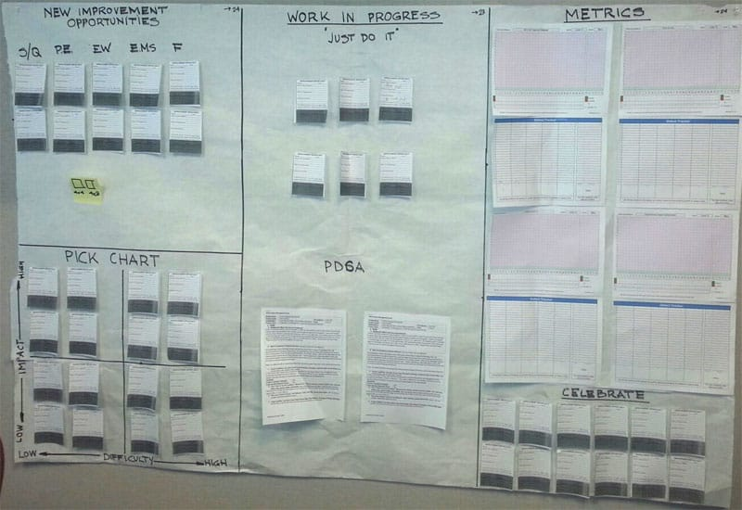

4.3 Kanban
Kanban visualizes and controls workflow.
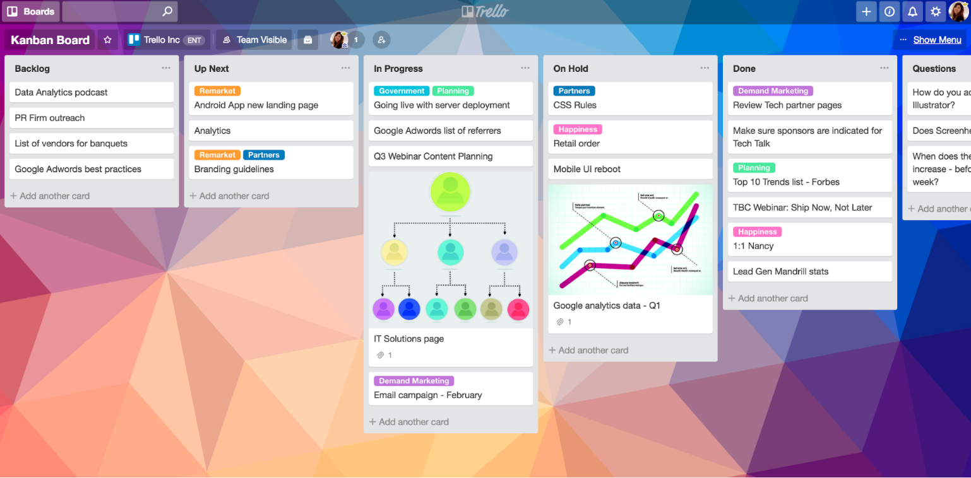
Example:
A support team uses a Kanban board with columns like To Do, In Progress, Testing, and Done to manage incident tickets efficiently.
Limiting work-in-progress prevents overload and improves response time.
5. Agile and Lean Integration in Practice
Agile ensures adaptability. Lean ensures efficiency.
Example:
A cloud services company uses Scrum for feature development and Kanban for production support, achieving faster releases with minimal waste.

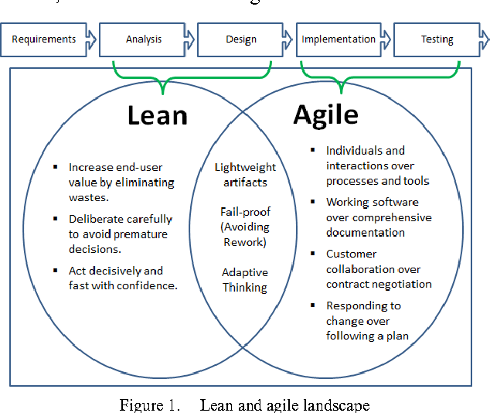
1. Understanding Agile as a Means of Assessing the Initial Status of a Project
Assessing the initial status of a project is critical for determining feasibility, risks, scope clarity, and stakeholder alignment. Agile provides structured mechanisms to perform this assessment early and continuously.
1.1 Vision and Product Backlog as Initial Assessment Tools
Agile begins with a clear product vision and a high-level product backlog. These artifacts help assess whether the project objectives are realistic and aligned with business needs.
Real-time example:
In a university ERP development project, the initial backlog contains modules such as admissions, examinations, and finance. By reviewing backlog size and priority, the team identifies that finance integration is complex and high-risk, requiring early attention.
1.2 Sprint 0 for Readiness Evaluation
Sprint 0 is often used to assess technical and organizational readiness.
It evaluates:
- Availability of stakeholders
- Infrastructure readiness
- Skill levels of the team
- Initial architectural decisions
Real-time example:
A healthcare startup uses Sprint 0 to verify compliance requirements, cloud infrastructure setup, and data security standards before actual feature development begins.
1.3 User Stories for Requirement Clarity
User stories help assess whether requirements are understandable and testable.
Real-time example:
In a travel booking application, vague requirements like “fast booking” are rewritten as user stories with acceptance criteria, revealing performance constraints that must be addressed early.
1.4 Estimation and Velocity Prediction
Story point estimation provides an early indication of effort and delivery timelines.
Real-time example:
A software services firm estimates 120 story points for an MVP. Based on historical velocity, the team realizes that the initial release will take three months instead of one, enabling early scope adjustment.
1.5 Risk Identification Through Early Iterations
Early sprints expose technical and business risks quickly.
Real-time example:
An IoT project identifies device connectivity issues in the first sprint itself, preventing large-scale failure in later phases.
2. How Agile Helps to Build Quality
Quality in Agile is built incrementally and continuously, rather than inspected at the end.
2.1 Quality Through Continuous Customer Feedback
Frequent reviews ensure that delivered features meet user expectations.

Real-time example:
In an online learning platform, instructors review each sprint’s output and request usability changes, reducing rework after final release.
2.2 Built-in Testing and Continuous Integration
Testing is integrated into each sprint.
- Unit testing
- Integration testing
- Automated regression testing
Real-time example:
A fintech application integrates automated tests into its CI pipeline, ensuring that every code commit is validated before deployment.
2.3 Definition of Done (DoD)
The DoD enforces quality standards.
Typical criteria include:
- Code reviewed
- Test cases passed
- Security checks completed
- Documentation updated
Real-time example:
A SaaS team refuses to mark a feature as “Done” unless it passes performance benchmarks, preventing quality degradation.
2.4 Technical Excellence and Refactoring
Agile encourages continuous refactoring.
Real-time example:
A ride-sharing platform refactors its pricing module regularly, enabling quick adaptation to surge pricing changes without defects.
2.5 Incremental Delivery Reduces Defects
Small increments make defect identification easier.

Real-time example:
In a banking application, transaction modules are released incrementally, allowing defects to be isolated and fixed early.
2.6 Retrospectives Drive Quality Improvement
Retrospectives identify root causes of quality issues.
Real-time example:
A development team notices repeated UI defects and introduces design reviews in subsequent sprints.
3. Agile Quality vs Traditional Quality Approach
Aspect | Traditional Approach | Agile Approach
Quality Focus | End-phase testing | Continuous
Feedback | Late | Early and frequent
Defect Cost | High | Low
Customer Involvement | Limited | Continuous

